The Director General

Malawi Revenue Authority

P/Bag 247

Blantyre

28th June 2023

Dear Sir,

**Re: Request for a duty waiver for medical instruments and consumables**

The British Society for Surgery of the Hand (BSSH) is a UK based charity (Charity Registration Number: 268396). We are writing to you to request a duty waiver on the following medical instruments and consumables:

INSERT LIST OF ITEMS

These items are carried by our volunteer VOLUNTEER NAME who will be visiting Lilongwe from DATES. These items will be used to conduct free surgeries of the hand for Malawian patients at the Lilongwe Institute of Orthopaedics and Neurosurgery (LION) unit at the Kamuzu Central Hospital as per our agreement with Dr. J Ngoma, Kamuzu Central Hospital Director and Dr Boston Munthali, Medical Director at the LION unit.

We are most grateful for your help in this matter.

Yours sincerely,

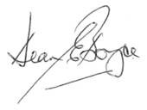

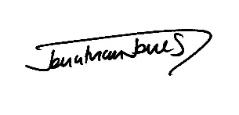

Mr Dean Boyce Mr Johnathan Jones

BSSH President BSSH/LION Leadership team