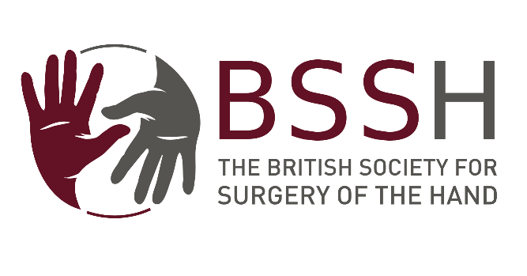 | Application Form  Education & Travel Bursary  Up to £2,500  BSSH Members

Personal Details
Full Name:
BSSH Member since:  (Year joined approx.) | Current Address:
Email:
Tel No:

Unit to be Visited
Name and Address of Unit:

Date of Proposed Visit:
Length of Visit:
Salary during Visit:

What do you hope to get out of the award?

Estimated Costs

Details of Other Sources of Funding

Declaration:
I, the undersigned, hereby declare that any money received by me from the British Society for Surgery of the Hand for the purpose of this bursary will be used solely for travelling expenses in connection with such bursary.

Signed: …………………………………………………………………………………………….. Date: ………………………

Print name in Capitals: ……………………………………………………………………………………………………………..

Closing date for application is 31st January for award in March and 31st July for award in September annually. The successful candidates will be contacted by email.

Successful applicants will be required to submit a short written report to the Education and Training Committee of the Society within 2 months of completion.

Please submit the completed form and an abridged CV electronically to secretariat@bssh.ac.uk

